Experiment Name: Connecting two computers with switch using packet tracer.

Equipment:

Procedure:

Step_1: Put two PC and one Generic Switch

PC0 and PC1, Switch0.

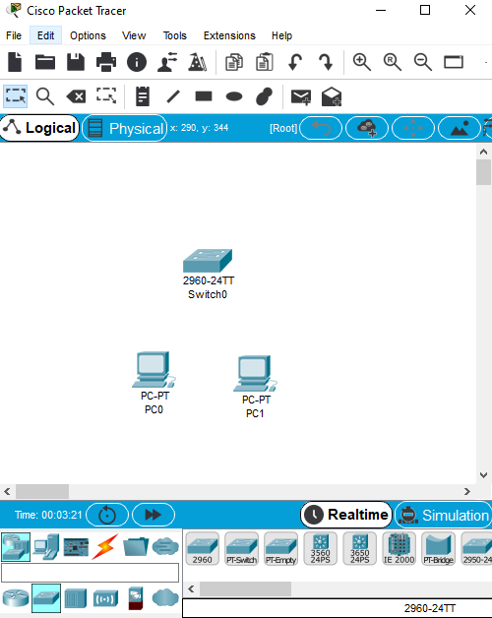

Step_2: Connect them all with copper straight cable.

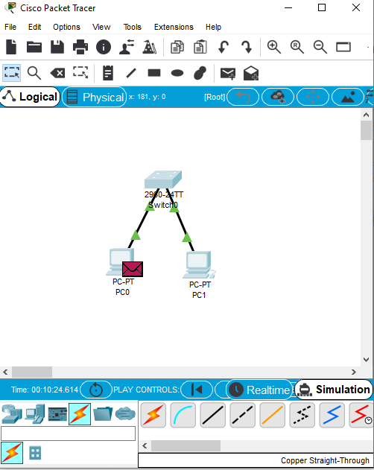

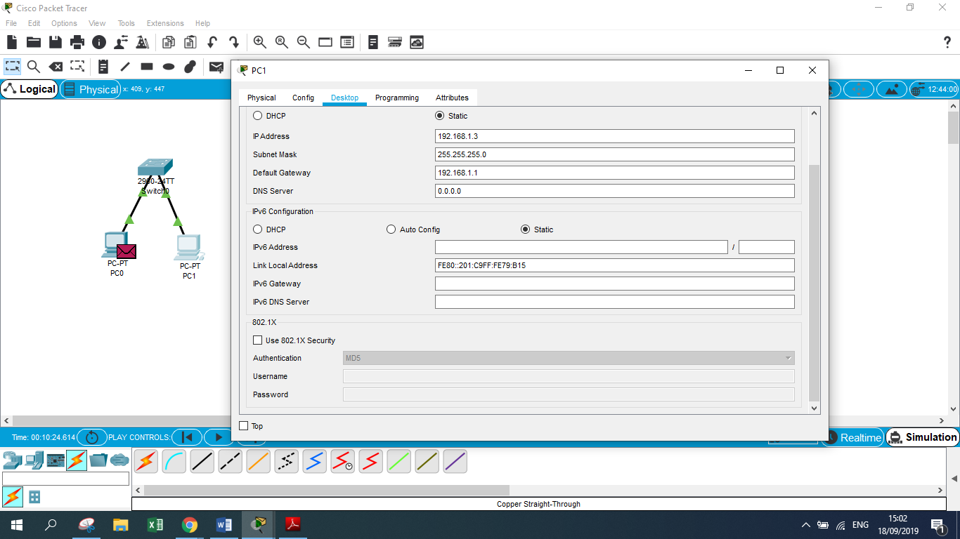Step_3: Set following IP and Mask

|  |  |  |  |
| --- | --- | --- | --- |
| PC Name | IP Address | Subnet Mask | Default Gateway |
| PC0 | 192.168.1.2 | 255.255.255.0 | 192.168.1.1 |
| PC1 | 192.168.1.3 | 255.255.255.0 | 192.168.1.1 |

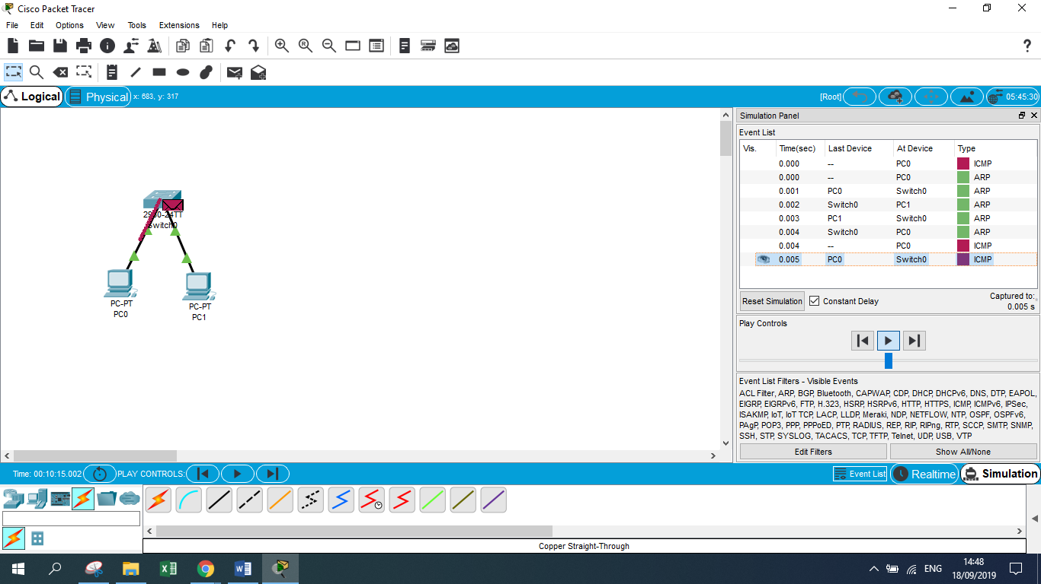

**Observation:** Though they are connected with each other with single switch only PC0 and PC1 can communicate with each other.

**Conclusion:** For two computers to communicate, they must be in same logical network.